In The Name of Allah
Unit :5 lesson :1
Done by : Nouf

Do you Know that !!!!
-Pollution affects the level of intelligence in human brain!!
-That pollution causes many diseases, including cancer!!
-that noise makes the baby crying in the womb!!-
1-The largest source of pollution is human
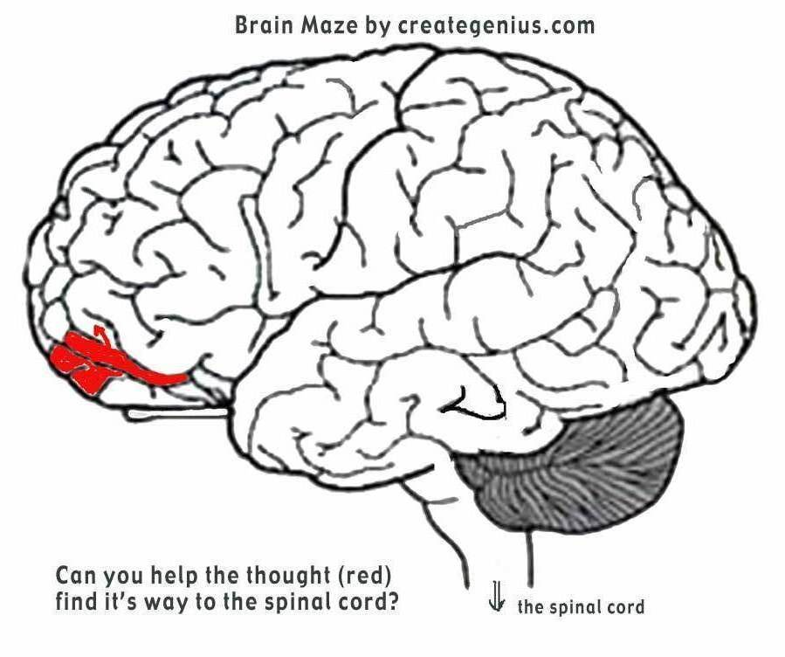

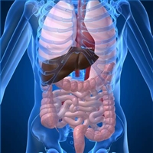

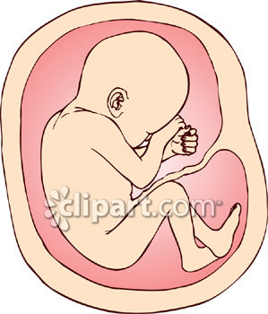


The four kinds of pollution & its causes :-
1-Water pollution by garbage and chemical

2-air pollution by smoking and fumes from cars

3-Land pollution by garbage of human being .

4-Noise pollution by cars and loud sounds

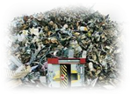



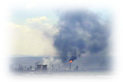

My dear students be friends with the environment & be sure you care about it

Comment in two sentences about the following pictures :
1-
2-
1-
2-
1-
3-

